# File permissions in Linux

## Project description

The task is to examine existing permissions on the file system. I’ll need to determine if the permissions match the authorization that should be given. If they do not match, I’ll need to modify the permissions to authorize the appropriate users and remove any unauthorized access.

## Check file and directory details

To check file and directory details, We can use the ls -la command.   
  
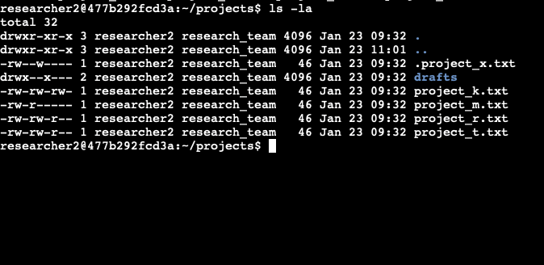

## Describe the permissions string

Let us take the permission string of the file project_k.txt: -rw-rw-rw-

It states that it is a file (-), the group has read and written permission, the user has read and written permission, and the other also has the same read and write permission.

## Change file permissions

The organization does not allow the others to have any write permissions for any files. So, we’ll now change the file’s permissions with the write permission. It is found that the project_k.txt file has given written permission to others. Now we’ll remove that permission. We can use the command: chmod o-w project_k.txt

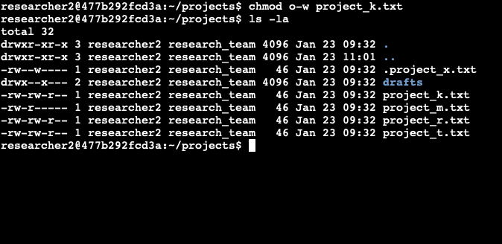

## Change file permissions on a hidden file

The research team has archived the file .project_x.txt file and that’s why it’s hidden. It is said that only the user and group should have read permissions and no one should have write permission. From the output of the previous section we can see that the user and group have written permission and now let us remove it. It can done using the command, chmod u-w,g-w .project_x.txt

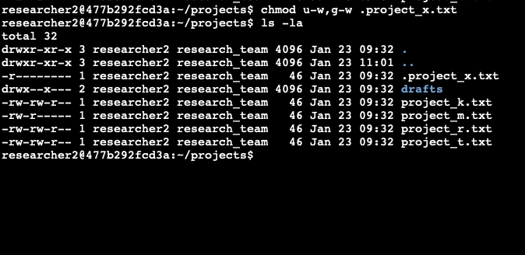

## Change directory permissions

The files and directories in the projects directory belong to the researcher2 user. Only researcher2 should be allowed to access the drafts directory and its contents. Now we’ll use a Linux command to modify the permissions accordingly. The command that will be used is chmod g-x drafts

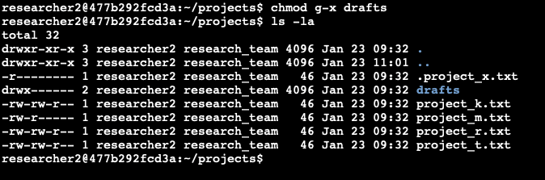

## Summary

The organization’s policy is that no others should have write permissions. The files in the projects are checked and necessary changes are made according to it and the outputs are added to this document for better understanding.